ADDRESS | AMOUNT | AVAILABILITY | VIEW | ADDITIONAL INFORMATION
PASSAIC COUNTY
146 Main Street  146 Main St, Paterson, NJ 07505 | Unit 304  Studio, 1 bath | $1,600 | NOW | 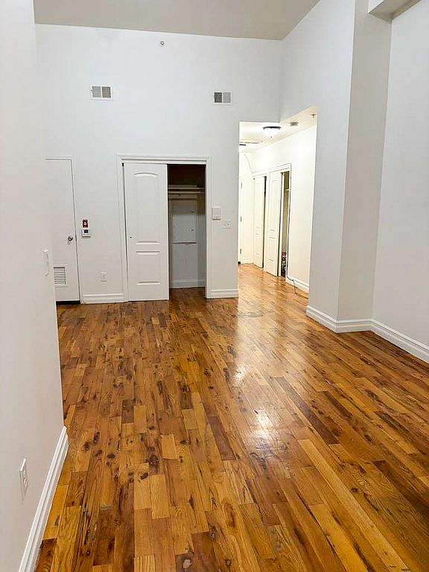 | Teresa Perez  Paramount Assets  (201) 817-4934  Small dogs  Allowed  Number allowed  1  Cats  Allowed  Number allowed  1  Large dogs are not allowed  146 Main St., Paterson, NJ - This newly renovated studio apartment offers approximately 580 square feet of well-designed living space, featuring hardwood floors throughout. The building is equipped with an elevator for added convenience, and public parking lots are available nearby. Ideally located, the property is just a 3-minute walk to the Broadway Bus Terminal and a 3-minute drive to the Paterson Train Station, providing easy access to public transportation and surrounding areas.  Credit score  625+  Office hours  Day Open hours  Mon - Fri: By appointment only  Sat: By appointment only  Sun: Closed  Available now  Pet-friendly  Monthly rent includes water, sewer, garbage disposal, and use of amenities if any. The tenant is responsible for all other utilities.  Lease length: One year lease  More building information  Garbage included in rent  Heating: Gas  Required  Application fee  $50  Pet deposit  $500  Refundable  One Year Lease  Sewage included in rent  Water included in rent
Gregory Plaza  260 Gregory Ave, Passaic, NJ 07055 | Small 1 BR  1 bed, 1 bath | $1,425 | NOW | 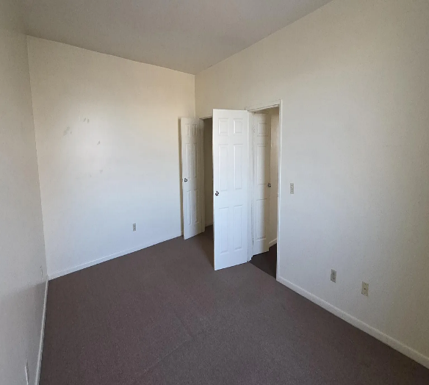 | **BECAUSE OF THE LEASE PROCESSING FEE OF 299.00, THIS APARTMENT IS NOT RECOMMENDED, HOWEVER, PROSPECTIVE RENTERS SHOULD USE THEIR OWN JUDGEMENT BASED ON THEIR NEEDS.  C.J. Lombardo Company  (201) 482-3037  Tenant pays all unities  Application fee  $75  Lease processing fee  $299  Optional  Pet deposit  Contact  Contact property for amount  Estimated total  $374  Freezer  Oven  Elevator  Refrigerator  Carpet  Range  More building information  Availability 24 Hours  Building-wide Wireless  Garbage included in rent  Heating: Gas  High-speed Internet Ready  One Year Lease  Sewage included in rent  Water included in rent  Walk to all at this conveniently located elevator building in Downtown Passaic. Our 24/7 on-site maintenance staff is experienced and superb. These go fast - Come find out why so many of our residents refer their friends and co-workers to our property.  Laundry: Shared  Security  Controlled Access  Intercom  Services & facilities  24 Hour Maintenance  Elevator  Unit Features  Appliances  Freezer  Oven  Range  Refrigerator  Flooring  Carpet  Heating  Gas  Internet/Satellite  Building-wide Wireless  Cable TV Ready  High-speed Internet Ready  Policies  Lease terms  One year
590 Main Ave #2, Passaic, NJ 07055 | $1,495/mo | NOW | 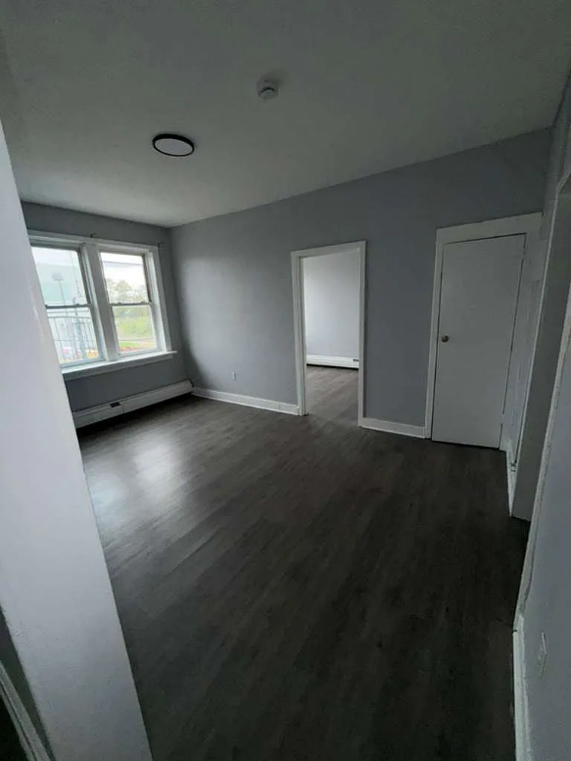 | BEWARE OF BASEBOARD HEATING, IF NOT PROPERLY MAINTAINED IT IS INEFFICIENT, HOWEVER, PROSPECTIVE RENTERS SHOULD USE THEIR OWN JUDGEMENT BASED ON THEIR NEEDS.  New Wave Estates  (973) 348-6716  Quiet building. Spacious floor plan  Studio apartment in a GREAT LOCATION, right on Main Ave in a quiet building (No Utilities Included). It is located near public schools, public transportation, shopping, dining and entertainment areas.  FEATURING: A spacious floor plan that includes a kitchen, main area, NO separate bedroom and a bathroom.  Tenant pays utilities. No smoking allowed. No pets allowed. 1 Year Lease-1.5 Month's Security Deposit- Background/Income/ Landlord Tenant Verification Required  Bedrooms: 0  Bathrooms: 1  Full bathrooms: 1  Pets allowed: No  Heating  Baseboard
111 Mill St FLOOR 2, Paterson, NJ 07501 | $1,550/mo | NOW | 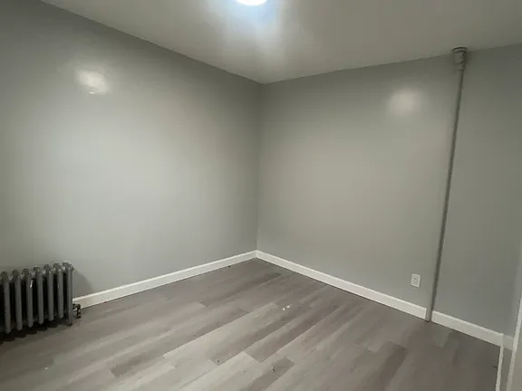 | Renee Renee  (862) 282-8139  This 900 square foot apartment home has 1 bedrooms and 1.0 bathrooms. This home is located at 111 Mill St FLOOR 2, Paterson, NJ 07501.  Bedrooms: 1  Bathrooms: 1  Full bathrooms: 1  Lease term: 1 Year
Freedom Village Senior 55+  69 Straight St, Paterson, NJ 07501 | $1,398 - $1,405 | Waiting List | 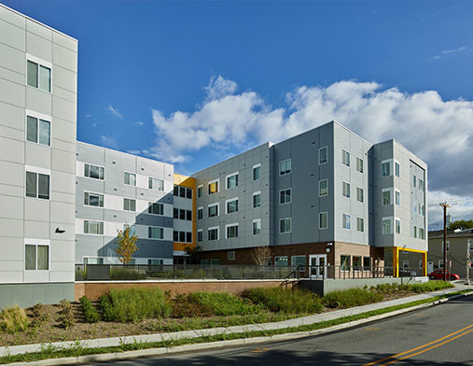 | BEWARE! IN THE PAST THIS COMPLEX HAS UNFAIRLY LIMITED BLACK SENIORS FROM ATTAINING APARTMENTS IN THIS COMPLEX, HOWEVER, PROSPECTIVE RENTERS SHOULD USE THEIR OWN JUDGEMENT BASED ON THEIR NEEDS.  (862) 281-6244  Apply today to join our waitlist! At Freedom Village, you’ll find a brand-new 55+ and 62+ senior apartments in Paterson, NJ, designed with your active lifestyle in mind. Please visit FreedomVillageNJ.com for more information and the pre-application. This fully gated community just steps from convenient public transportation will allow you to live the active, exciting life you desire! In each one-bedroom apartment, you’ll find an open design and large windows that make coming home something special. Adding to these wonderful comforts, you’ll also enjoy all of the extras at Freedom Village such as our community room, on-site fitness center and a variety of resident services. This is the kind of home you’ve been looking for. At Freedom Village, we bring it all together. Applicants for the subsidized units at Freedom Village must be referred by the Paterson Housing Authority.  Freedom Village Senior 55+ is an apartment community located in Passaic County and the 07501 ZIP Code. This area is served by the Paterson Public attendance zone.  Unique Features  Ceramic-Tiled Baths  Community Kitchenette  Individually Controlled Cooling  Individually Controlled Heating  Senior Community  24-Hour Emergency Call Service  Oversized Windows  Healthcare Suite  Open Floor Plans
ESSEX COUNTY
Forest Hill Terrace  325 Grafton Ave, Newark, NJ 07104 | Studio  Studio, 1 bath | $1,600 | NOW | 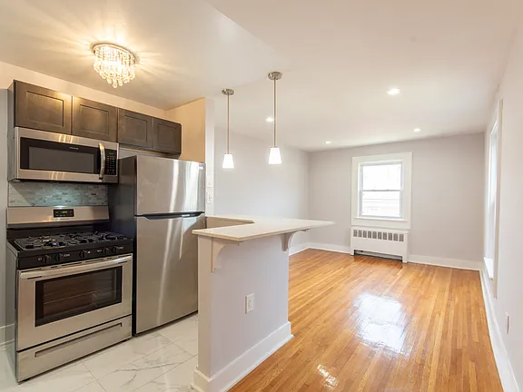 | Alex Inoa  (201) 308-0926  Welcome to Forest Hill Terrace, where classic architecture blends with modern upgrades in the heart of Newark's prestigious Forest Hill neighborhood. This beautifully renovated apartment offers an unbeatable combination of style, comfort, and convenience just steps from Branch Brook Park and easy transit access.w  Office hours  Day Open hours  Mon - Fri: 10 am - 6 pm  Sat: Closed  Sun: Closed  Apartment building  Studio-1 bed  Pet-friendly  Parking lot  Shared laundry  Some of the staff speak Spanish  This building features Spanish speaking staff. Less than 12% of buildings in Newark offer this.  Quiet tree-lined residential block  Oversized windows  Modern upgrades  Sun-drenched rooms  Classic architecture  Beautifully renovated apartment  Hardwood floors
654 Lyons Avenue  654 Lyons Ave, Irvington, NJ 07111 | One bedroom  1 bed, 1 bath | $1,495 | NOW | 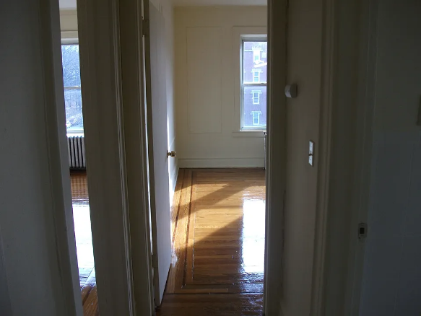 | I & S Management  (973) 370-8819  12 Month  Oven  Elevator  Hardwood  Range  More building information  Availability 24 Hours  Garbage included in rent  Heating included in rent  Heating: Gas  High-speed Internet Ready  Hot water included in rent  One Year Lease  Online Rent Payment  Sewage included in rent  Water included in rent  Estimate your total  Monthly rent, fees & charges  Required  Monthly base rent  $1,495+  Optional  Pet rent  --  Pets not allowed  Laundry: Shared  Security  Controlled Access  Services & facilities  24 Hour Maintenance  Elevator  Online Rent Payment  Estimated monthly total  $1,495+  One-time fees & charges  Required  No required one-time fees provided  Optional  Pet deposit  --  Pets not allowed
10-38th Street  10 38th St, Irvington, NJ 07111 | One bedroom  1 bed, 1 bath | $1,495 | NOW | 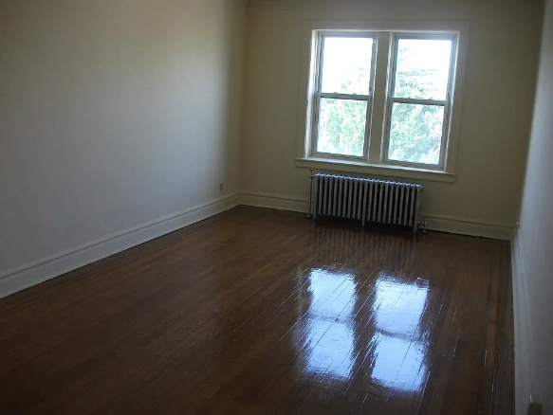 | 12 Month Lease  Oven  Elevator  Hardwood  Range  More building information  Availability 24 Hours  Garbage included in rent  Heating included in rent  High-speed Internet Ready  Hot water included in rent  One Year Lease  I & S Management  (973) 846-9184  Elevator building conveniently located near shopping venues and major highway. Live in super on premises and 24 hour maintenance on call for emergencies. Heat and hot water included in all units.  Online Rent Payment  Sewage included in rent  Water included in rent  Estimate your total  Monthly rent, fees & charges  Required  Monthly base rent  $1,495+  Optional  Pet rent  --  Pets not allowed  Estimated monthly total  $1,495+  One-time fees & charges  Required  No required one-time fees provided  Optional  Pet deposit  --  Pets not allowed  Office hours  Day Open hours  Mon - Fri: 8:30 am - 5 pm  Sat: Closed  Sun: Closed
Madison Avenue  290 Madison Ave, Irvington, NJ 07111 | One bedroom  1 bed, 1 bath | $1,395 | NOW | 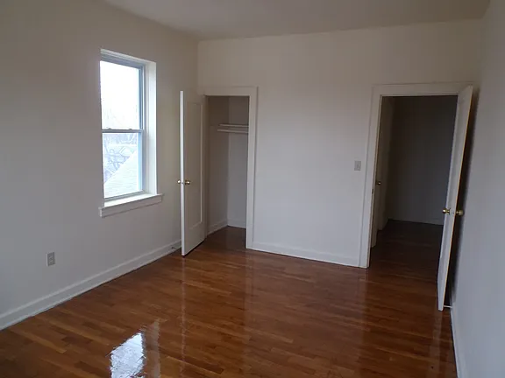 | I & S Investment  (973) 264-0073  Elevator in building  Apartment building conveniently located near major highways. All apartments include heat and hot water. Elevator in building as well as 24 hour maintenance on call for emergencies.  12-month lease  Oven  Elevator  Hardwood  Range  More building information  Availability 24 Hours  Heating included in rent  Heating: Gas  High-speed Internet Ready  Hot water included in rent  One Year Lease  Online Rent Payment  Sewage included in rent  Water included in rent  Laundry: Shared  Security  Controlled Access  Services & facilities  24 Hour Maintenance  Elevator  Online Rent Payment  Unit Features  Appliances  Oven  Range  Cooling  Wall Mounted Air Conditioning  Flooring  Hardwood  Heating  Gas  Internet/Satellite  Cable TV Ready  High-speed Internet Ready  Policies  Parking  None  Lease terms  One year  Pet essentials  Skip to the end of the carousel  Dogs  Dogs are not allowed  Cats  Cats are not allowed  Pet rent  --  Pets not allowed  No required one-time fees provided
Brookdale Gardens  935 Broad St, Bloomfield, NJ 07003 | $1,575/mo  935 Broad St #EH, Bloomfield, NJ 07003 | NOW | 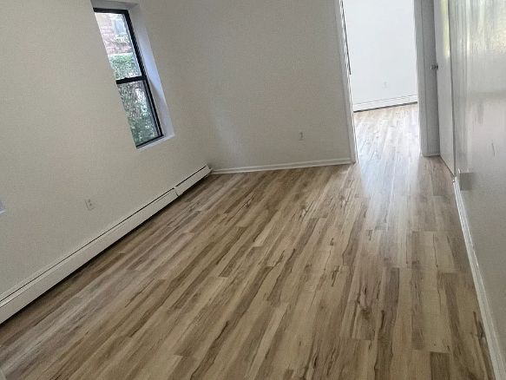 | Leasing Agent  (973) 545-7354  Brookdale Gardens is built on twenty acres in a park-like setting surrounded by trees and open spaces. Bloomfield's biggest advantages are it's closeness to excellent schools, Bloomfield College and Hoffman LaRoche parks, transportation in N.J. and twenty minutes to N.Y.C. and a short distance to Newark's new cultural center and airports. All prices include hot water and heat!  Special offer! one month free rent on select units!  Expires January 31, 2026  $1,575/mo  935 Broad St #EH, Bloomfield, NJ 07003  There are 3 available units in this apartment building  Apartment  Available now  No pets  Shared laundry  Off street parking + 1  Electric, natural gas
UNION COUNTY
610 Salem Ave, Elizabeth, NJ 07208 | $1,549/mo | NOW | 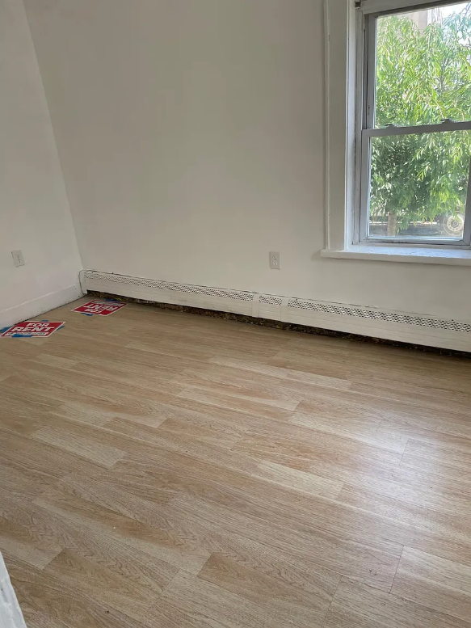 | Leasing Agent  (973) 604-8790  In-unit laundry  Fresh sheets when you want them  This building features in-unit laundry. Less than 20% of buildings in Elizabeth have this amenity.  Gross income per month Income can include, but isn't limited to: W-2 or 1099 pay checks, Social Security payments, Housing vouchers  2.5x rent  Credit score  600+  Pet policy Cats and dogs  Laundry: In Unit  Services & facilities  24 Hour Maintenance  Online Maintenance Portal  Appliances  Convection Oven  Dryer  Freezer  Microwave Oven  Oven  Range  Refrigerator  Washer  Cooling  Window Mounted Air Conditioning  Flooring  Hardwood: HARDWOOD FLOORING  Laminate  Marble: MARBLE FLOORING  Tile: MARBLE TILE KITCHENS AND BATHROOMS  Vinyl  Heating  Gas  Other  Brand New Countertops  Fully Renovated  Granite Counter Tops  Granite Counters  Granite Countertops  Recessed Lighting  Stainless Steel Appliances  Tiled Kitchen And Bathroom  Policies  Lease terms  One year  Pet essentials  Skip to the end of the carousel  Small dogs  Allowed  Cats  Allowed
Shami Apartments  400 Hamilton St, Rahway, NJ 07065 | Studio  Studio, 1 bath | $1,150 | NOW | 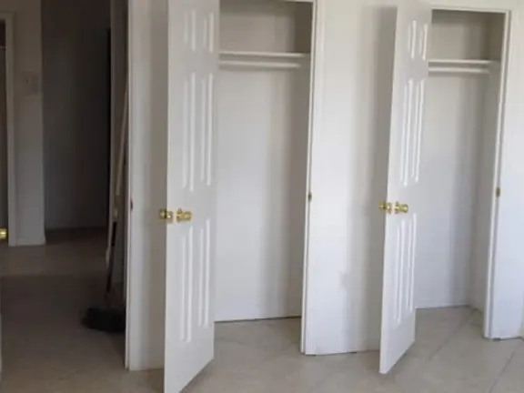 | Shami Apartments Leasing Agent  (267) 843-8258  Pet rent  Contact  Contact property for amount  No required one-time fees provided
Sheridan Gardens  1093 Sheridan Ave, Elizabeth, NJ 07208 | Unit 1104C  Studio, 1 bath | $1,400 | NOW |  | Property Manager Maria  (908) 356-4132  Other  Laundry: None  Services & facilities  24 Hour Maintenance  On-Site Management  Online Rent Payment  Unit Features  Appliances  Freezer  Oven  Range  Refrigerator  Flooring  Hardwood  Laminate  Tile  Heating  Gas  Policies  Parking  Parking Lot  Lease terms  One year  Pet essentials  Dogs  Dogs are not allowed  Cats  Cats are not allowed  Available now  About the unit  LEASE TERM IS 1 YEAR  Freezer  Laminate  Oven  Tile  Refrigerator  Hardwood  Range  Lease terms  Lease length: One year lease  More building information  1 PARKING SPACE ALLOWED PER APARTMENT.  Garages at additional cost when available  Availability 24 Hours  Flooring: Laminate  Heating included in rent  Heating: Gas  Hot water included in rent  On-Site Management  One Year Lease  Online Rent Payment  Estimate your total  Monthly rent, fees & charges  Required  Monthly base rent  $1,400  Optional  Pet rent  --  Pets not allowed  Estimated monthly total  $1,400  One-time fees & charges  Required  Application fee  $50  Security deposit  $1,875 - $3,225  Optional  Pet deposit  --  Pets not allowed
1011 East Jersey Street  1011 E Jersey St, Elizabeth, NJ 07201 | $1,599/mo | NOW | 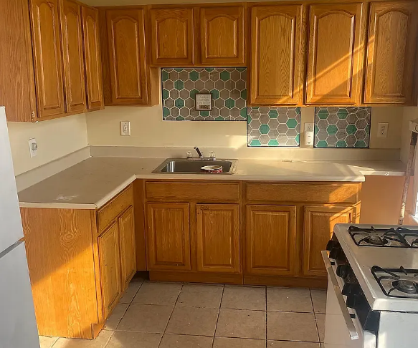 | MNS Rentals  Verified Source  (551) 465-9164  Large Layout 1-2 BR units on East Jersey Street Right off Route 1-9 in Elizabeth!  Apartments Feature:  Renovated Kitchens and Bathrooms  Hardwood Flooring  Freshly Painted  Off Street Parking for additional fee (If Available)  Heat and Hot Water Included  Laundry On Site  Easy Access to NYC!  To Qualify:  630+ Credit Score, Income at least 2.5 X The rent after taxes  To Apply:  Each Adult over 18 moving in must apply. $35 application fee per adult moving in. Three (3) Recent Paystubs, Photo ID and SS Card required.  One Year lease, No Dogs  Gross income per month Income can include, but isn't limited to: W-2 or 1099 pay checks, Social Security payments, Housing vouchers  2.5x rent  Credit score  640+  Pet policy  Cats only
POSSIBLE ROOMS FOR RENT IN NEWARK NJ
79 Columbia St. Newark | 201-591-1100 Ext 216 | Ashley
83 Green St. Newark | •  201-591-1100 Ext 216 | Ashley
168 Clinton Ave. Newark | 201-591-1100 Ext 216 - | Ashley
69-77 Pennsylvania Ave Nwk | 201-591-1100 Ext 216 | Ashley
1163 Court St. Newark | 201-591-1100 Ext 216  ' . | "  Ashley
468 Washington St .Newark | 201-591-1100 Ext 216 | Ashley
471 Washington St .Newark | 201-591-1100 Ext 216 | Ashley  ..
472 Washington St. Newark | 201-591-1100 Ext 216 | Ashley  ..
474 Washington St. Newark | 201-591-1100 Ext 216 | Ashley
476 Washington St. Newark | 201-591-1100 Ext 216 | Ashley
667 Clinton Ave. Newark | 201-591-1100 Ext 216 | Ashley
75 Baldwin St. Newark | 201-591-1100 Ext 216 | Ashley
52 S. Walnut St East Orange | 201-591-1100 Ext 216 | Ashley
70 Chestnut St East Orange | 201-591-1100 Ext 216 | Ashley
811 Bergen St. Newark | 954-675-5359 | Mattv Green
31 South Street Newark | 732-382-2067 | Lucy
66 Sherman Ave.. . Newark | 201-591-1100 Ext 216 | Ashley
1182 Elizabeth Ave. Elizabeth NJ | 973-624-3300 | Jim Cooper
1'123 Magnolia Ave. Elizabeth NJ | 973-624-3300 | Jim Cooper
1039 Mitgnolia Ave. Elizabeth NJ | 973-624-3300 | Jim Cooper  ,.

